SuiteCommerce Standard.
Hide paypal button for buyers from the US, only people outside US can use paypal.
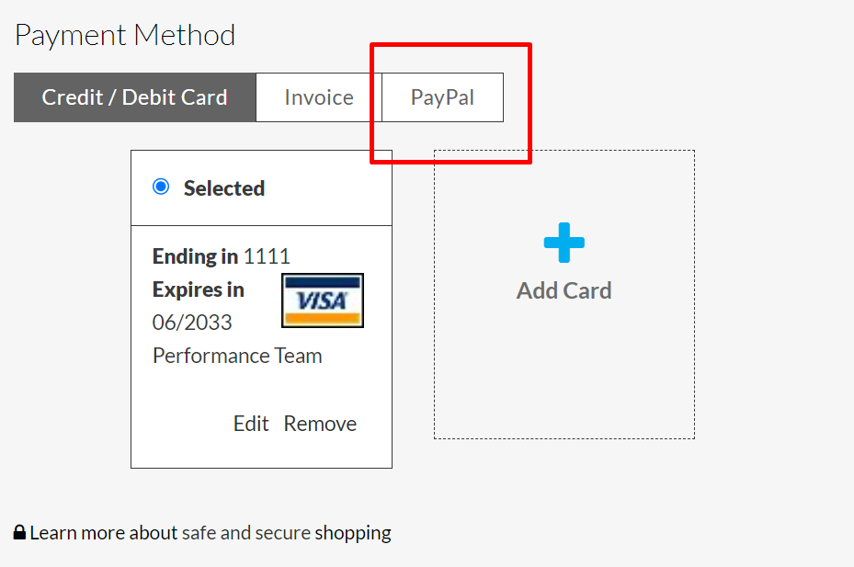
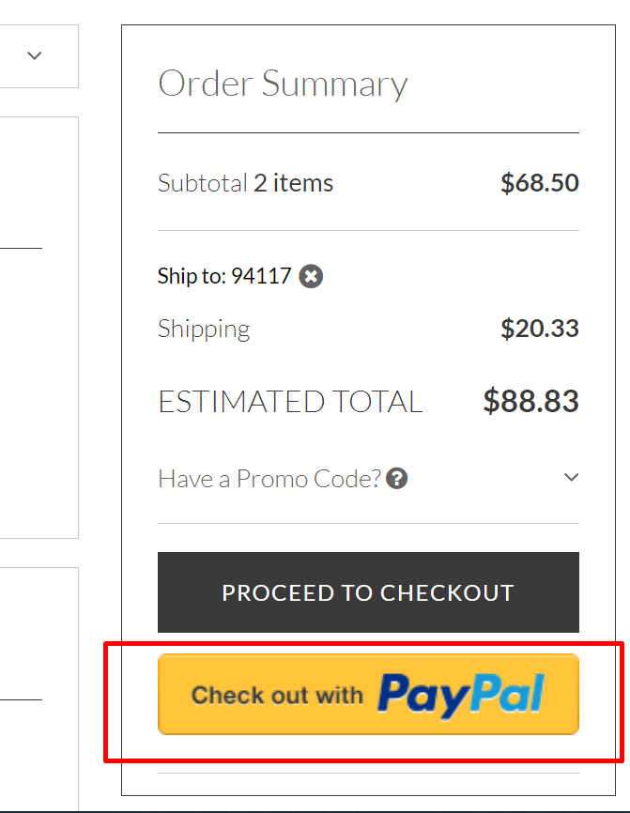

After Show content

Then do a service and check

For checkout steps?? We can’t use that

